**Thermal design:**

Thermal design one of the most important considerations in the power electronic circuits because there a lot of power handling electronic components and unfortunately, these devices does not work at %100 efficiency. Therefore, some of the losses should be dissipated as heat through these components. However, these devices can not tolerate that much heat by itselves. Thus, additional mechanical parts should be integrated with them to ease the dissipation of the heat. Additionally, not just because the safety of the components, but also, performance and life-time of the components are mostly determined by thermal design so, it should be implemented for those reasons.

For our circuit, there are two parts that dissipate heat significantly, These are rectifier unit, and buck converter. Since we have one compact rectifier module and also diode and mosfet which form buck converter connected to same heatsink, two heatsinks are used totally.

while selecting heatsinks, not just driving at no load is considered but also robustness bonus is considered. Therefore, calculations are made for both requirements as follows.

**Calculations:**

for the first, the heatsink for buck converter is calculated

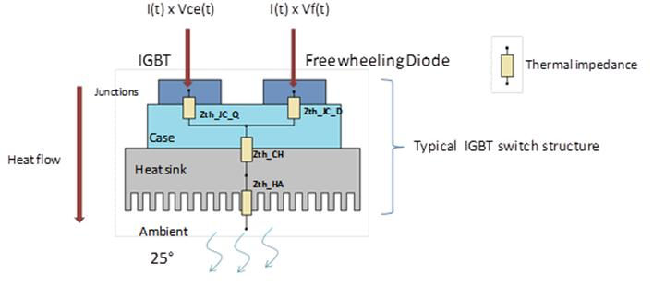

figure??: thermic lumped parameter model of the buck converter.

* First we assume the thermal contact between the heatsink and component are neglible so, we neglect that part.
* Secondly, we should calculate total power loss to select the suitable heatsink.

For that purpose, we should look back to datasheet of the diode and IGBT to obtain the pararameters for both conduction losses and switching losses.

firstly , we use DHG30I600PA diode and its parameters are as follows:

**(*) V**fo=1.17V.

(**) rF=32 mΩ.

And for the Switching losses,

(we already know the fs=500Hz and Vr =200V at most)

We just need to find Qr from following graph.

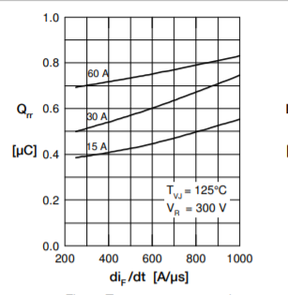

Figure?? Qr vs dif/dt from datasheet.

From above figure we Assume Qr as 0.3 uA at worst situation because the current that pass through the diode never exceeds the 10A.

So, we can insert those values to the equations,

Pcd= (1.170.032)10(we assume at most diode conduct 10 A which is still lover than rated operation of the project

Psd=0.30 (since frequency is low it is normal)

Psd+Pcd=15 Watt at total contribution from diode.

Now we can calculate the losses for the IGBT.

For the conduction losses of IGBT,

**Vce**=1.6 V (collector emitter sat. voltage)

**If=**10 A ( for a safety margin. normally it depends on duty cycle)

Pic= 16 Watt .

For the Switching losses, we should obtain the energy required for opening and closing.

We choose the “IGW30N60T” IGBT and from its datasheet, ETOTAL=1.8 mJ

the frequency of operation is around 500Hz and that energy will be given and taken in one interval of operation. Therefore, we should multiply fS with the ETOTAL to find switching loss.

Pis=fS (it expected since frequency is so low)

Therefore, total contribution from IGBT is 17 watt.

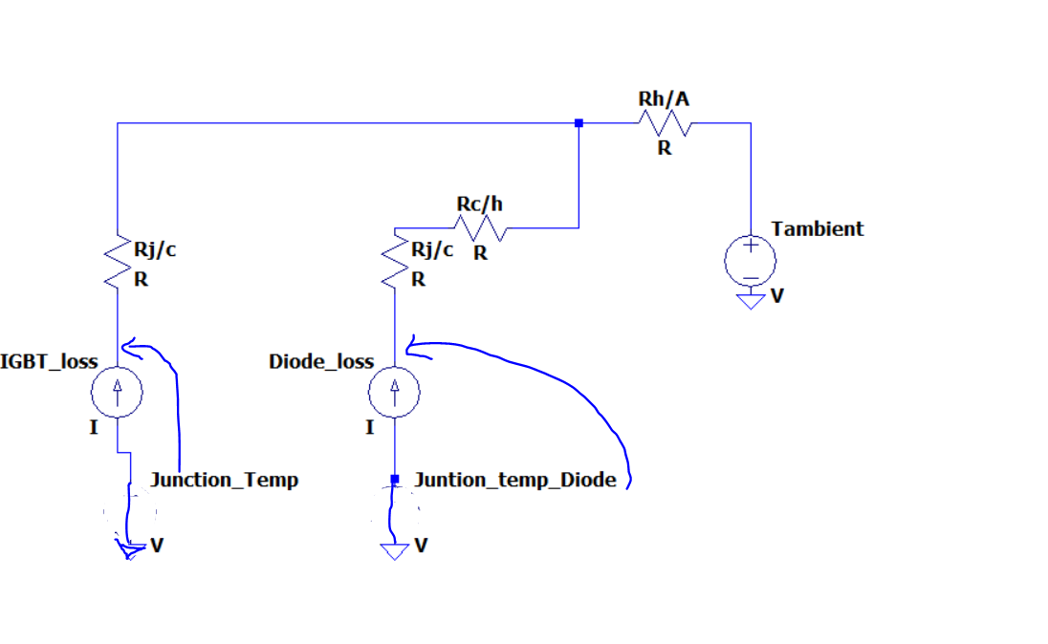

Figure??: detailed lumped model of thermal design.

* Thirdly, we should find the thermal resistances from the datasheets and guessing a reasonable heatsink value from these results.

**Rj/c(diode)=0.7 C/W , Rc/H(diode) =0.5 C/W Rtotal=1.2C/W**

**Rj/c(IGBT)=0.8 C/W**

if we assume heatsink has 1.0 C/W thermal resistance then the junction temperatures will become as below:

Tj(diode)=25+15321=75 C.

Tj(IGBT)=25+170.8+321=70.6 C.

These are far less values that the maximum operating junction temperature which is 175 C degrees so, we select a heatsink which has 0.9 C/W thermal resistance to realize the that idea.

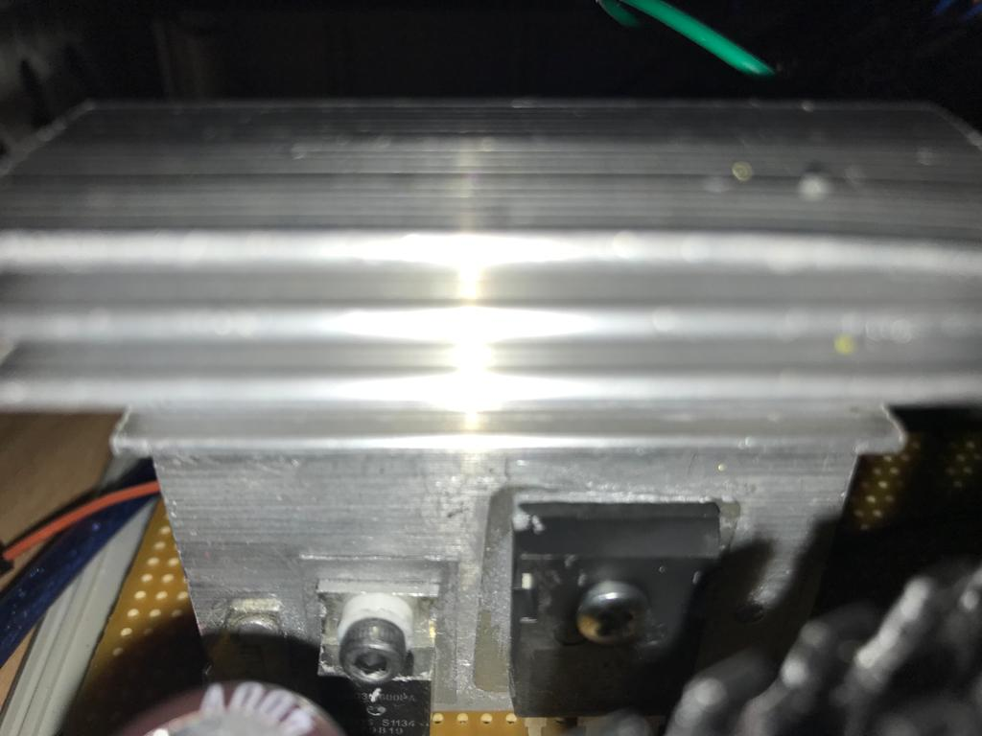

Figure??: Resultant hardware configuration of thermal design (for buck converter)

For the Second, we will calculate the heatsink required for the Three-phase full bridge rectifier,

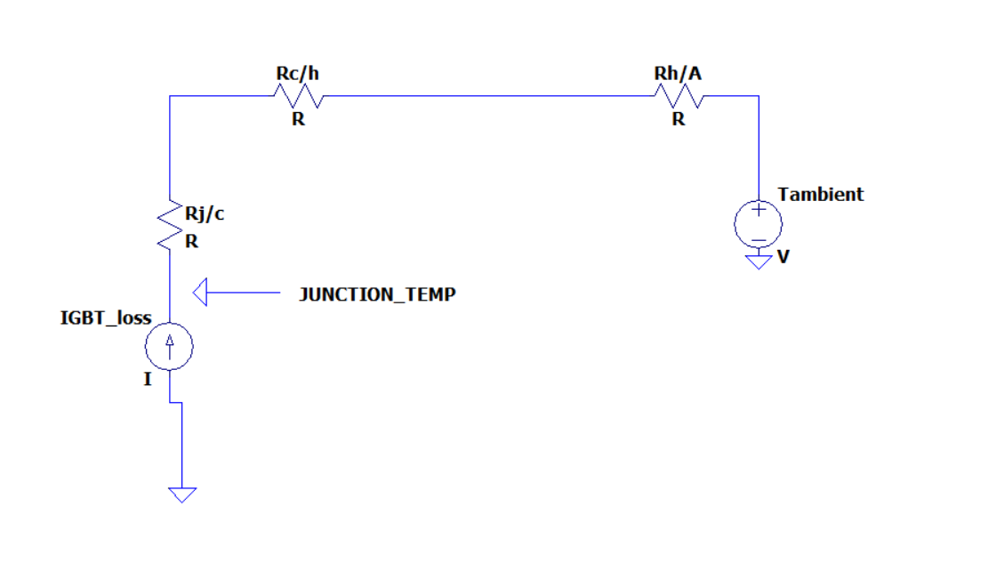

Figure:?? the detailed lumped model of the bridge module.

So, Again we should calculate the losses and applying the same procedures above for the selecting a suitable heatsink.

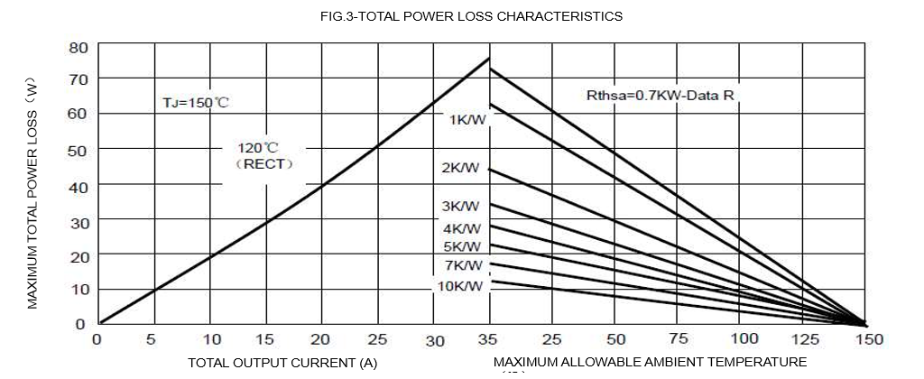

Figure??: power loss characteristic of the bridge module. (from datasheet)

Since we have a bridge module rather than six single diodes, accessing the datasheet of the diodes inside of the module is not possible. In datasheet provided for complete module includes some general power loss characteristic as in the figure above. this curve gives the maximum power loss therefore, it will be safe to use it although it may results with unnecessarily large heatsink.

Ploss= 20 Watt (at 10A output).

So, it is now time to find thermal parameters from the same datasheet.

**Rj/c**=1.16 C/W.

**Rc/h=**0.2 C/W.

So, we try with a 1.8C/W heatsink and result will be:

Tj=(1.16+0.2+1.8)20=88 C

So, it is again relatively safe for the operation of this project.

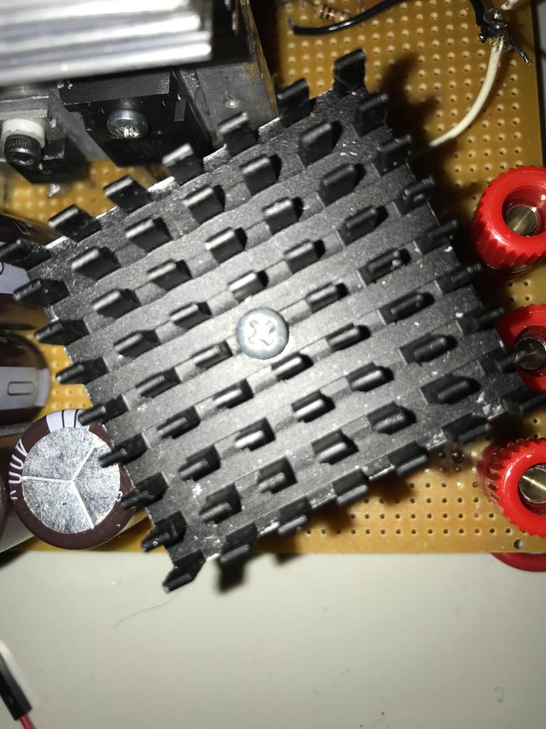

Figure:?? the heatsink for the full bridge rectifier.

<https://www.aliexpress.com/i/32634872516.html>